Table of Contents

Summary: 2

Key terms 2

Discussion questions 3

Self-test 4

Chapter 1 Rapid review: 5

What is operation management? 5

Organizing to produce goods and services 5

The supply chain 5

Why study OM? 5

What operations managers do 5

The heritage of operations management 6

Operations for Goods and Services 6

The productivity challenges 6

Current challenges in operations management 7

Ethics, social responsibility, and sustainability 7

Work study 8

Method study 8

Advantages of method study 8

Work measurement 8

Purpose of work measurement 8

Advantages of work measurement 9

Techniques of work measurement 9

Advantages of workstudy 9

Time and motion study 10

Time study 10

Motion study 10

Difference between time and motion study 11

Methods engineering 11

Steps of Methods Engineering 11

Scope of method study 12

Production 12

Productivity 12

Types of productivity 12

Aggregate productivity 12

Partial productivity 12

Difference between production Vs Productivity 13

Why productivity measured 13

Production / operation management 14

Factor influencing productivity 14

Controllable or internal factors of productivity 14

Uncontrollable factors 14

Possible Quiz Questions 15

# Summary:

Operations, marketing, and finance/accounting are the three functions basic to all organizations. The operations function creates goods and services. Much of the progress of operations management has been made in the twentieth century, but since the beginning of time, humankind has been attempting to improve its material well-being. Operations managers are key players in the battle to improve productivity.

As societies become increasingly affluent, more of their resources are devoted to services. In the U.S., more than 85% of the workforce is employed in the service sector. Productivity improvements and a sustainable environment are difficult to achieve, but operations managers are the primary vehicle for making improvements.

# Key terms

1. Production, pg 36
2. Operation management (OM), pg 36
3. Supply chain, (pg 38)
4. 10 strategies OM decisions, pg 39
5. Services, pg 43
6. Service sector, pg 44
7. Productivity, pg 45
8. Single-factor productivity, pg 46
9. Multifactor productivity, pg 46
10. Productivity variables, pg 47
11. Knowledge society, pg 48
12. Stakeholders, pg 51

# Discussion questions

1. Why should one study operations management?
2. What are some career opportunities in the operations management discipline?
3. Identify four people who have contributed to the theory and techniques of operations management.
4. What are the three basic functions of a firm?
5. Identify the 10 strategic operations management decisions.
6. What are the measurement problems that occur when one attempts to measure productivity?
7. Mass customization and rapid product development were identified as challenges to modern manufacturing operations. What are the relationships, if any, between these challenges? Can you cite any examples?
8. What are the five reasons productivity is difficult to improve in the service sector?

# Self-test

1. Productivity increases when:
2. Inputs increase while outputs remain the same.
3. Inputs decrease while outputs remain the same.
4. Outputs decrease while inputs remain the same.
5. Inputs and outputs increase proportionately.
6. Inputs increase at the same rate as outputs.
7. A strategy that is not one of the 10 strategic operations management decisions is:
8. Maintenance.
9. Human resources, job design and work measurement.
10. Location strategies.
11. Design of goods and services.
12. Advertising strategies.
13. Operations management jobs comprise approximately ___% of all jobs.
14. Services often:
15. Are tangible.
16. Are standardized.
17. Are knowledge based.
18. Are low in customer interaction.
19. Have consistent product definition.
20. Productivity:
21. Can use many factors as the numerator.
22. Is the same thing as production.
23. Increases at about 0.5% per year.
24. Is dependent upon labor, management, and capital.
25. Is the same thing as effectiveness.
26. Single – factor productivity:
27. Remains constant.
28. Is never constant.
29. Usually uses labor as a factor.
30. Seldom uses labor as a factor.
31. Uses management as a factor.
32. Multifactor productivity:
33. Remains constant.
34. Is never constant.
35. Usually uses substitutes as common variables for the factors of production.
36. Seldom uses labor as a factor.
37. Always uses management as a factor.
38. Productivity increases each year in the U.S. are a result of three factors:
39. Labor, capital, management
40. Engineering, labor, capital
41. Engineering, capital, quality control
42. Engineering, labor, data processing
43. Engineering, capital, data processing.

Answers: 1: b, 2: e, 3: 40, 4:c, 5: d, 6: c, 7: c, 8: a,

# Chapter 1 Rapid review:

## What is operation management?

1. Production – the creation of goods and services.
2. Operations management (OM) – activities that relate to the creation of goods and services through the transformation of inputs to outputs.

## Organizing to produce goods and services

All organizations perform three functions to create goods and services:

1. Marketing, which generates demand
2. Production/operations, which creates the product
3. Finance/accounting, which tracks how well the organization is doing, pays the bills, and collects the money.

## The supply chain

Supply chain – a global network of organizations and activities that supply a firm with goods and services.

## Why study OM?

We study OM for four reasons:

1. To learn how people organize themselves for productive enterprise.
2. To learn how goods and services are produced.
3. To understand what operations managers, do.
4. Because OM is a costly part of an organization.

## What operations managers do

Ten OM strategies decisions are required of operations managers:

1. Design of goods and services
2. Managing quality
3. Process strategies
4. Location strategies
5. Layout strategies
6. Human resources
7. Supply chain management
8. Inventory management
9. Scheduling
10. Maintenance

About 40% of all jobs are in OM. Operations managers possess job titles such as plant manager, quality manager, process improvement consultant, and operations analyst.

## The heritage of operations management

Significant events in modern OM can be classified into six eras:

1. Early concepts
2. Scientific management
3. Mass production
4. Lean production
5. Mass customization
6. Globalization era

## Operations for Goods and Services

1. Services – economic activities that typically produce an intangible product (such as education, entertainment, lodging, government, financial, and health services). Almost all services and almost all goods are a mixture of a service and a tangible product.
2. Service sector – the segment of the economy that included trade, financial, lodging, education, legal, medical, and other professional occupations. Services now constitute the largest economic sector in postindustrial societies. The huge productivity increases in agriculture and manufacturing have allowed more of our economic resources to be devoted to services. Many service jobs pay very well.

## The productivity challenges

1. Productivity – the ratio of outputs (goods and services) divided by one or more inputs (such as labor, capital, or management)

High production means producing many units, while high productivity means producing units efficiently.

Only through increases in productivity can the standard of living of a country improve. U.S. productivity has averaged a 2.5% increase per year for over a century.

$$single-factor productivity=\frac{units produced}{input used}$$

1. Single – factor productivity:

Indicates the ratio of goods and services produced (outputs) to one resources (input).

1. Multifactor productivity:

Indicates the ratio of goods and services produced (outputs) to many or all resources (inputs).

Multifactor productivity

$$=\frac{output}{labor+Material+Energy+Capital+Miscellaneous}$$

Measurement problems with productivity include:

1. The quality may change,
2. External elements may interfere, and
3. Precise units of measure may be lacking.
4. Productivity variables – the three factors critical to productivity improvement are labor (10%), capital (38%), and management (52%).
5. Knowledge society – a society in which much of the labor force has migrated from manual work to work based on knowledge

## Current challenges in operations management

Some of the current challenges for operations managers include:

1. Global focus; international collaboration
2. Supply chain partnering; joint ventures; alliances
3. Sustainability; green products; recycle, reuse
4. Rapid product development; design collaboration
5. Mass customization; customized products
6. Lean operations; continuous improvement and elimination of waste

## Ethics, social responsibility, and sustainability

Among the many ethical challenges facing operations managers are

1. Efficiently developing and producing safe, quality products;
2. Maintaining a clean environment;
3. Providing a safe workplace; and
4. Honoring stakeholder commitments.
5. **Stakeholders – those with a vested interest in an organization**

## Work study

* Branch of industrial engineering
* Combination of 2 techniques
* Method study, work measurement

## Method study

* To simplify the job and develop more economical methods of doing it.
* Systematic recording and critical examination of existing and proposed ways of doing a work, as a means of developing and applying easier and more effective methods and reducing costs.

## Advantages of method study

1. Improved working processes
2. Better work place layout
3. Less fatigue to workers
4. Better product quality
5. Effective utilization of resources
6. Efficient, fast material handling
7. Reduced health hazards
8. Efficient planning of section
9. Streamlined working procedures

## Work measurement

* To determine how long it should take to carry out.
* Application of techniques designed to establish the time for a qualified worker to carry out a specified job at a defined level of performance.
* The role of work study: work measurement: to investigate existing practice, locate ineffective time and set standards of performance as a basis for-

1. Planning and control
2. Utilization of plant
3. Labor cost control
4. Incentive schemes

## Purpose of work measurement

1. To evaluate workers performance
2. To evaluate the existence of ineffective time
3. To determine available capacity
4. To determine price or cost of a product
5. To compare work methods
6. To facilitate operations scheduling
7. To establish wage incentive schemes

## Advantages of work measurement

1. Determines time required, establishes fastest methods;
2. Determines man power required for a job;
3. Decides equipment’s;
4. Provides information for effective production planning;
5. Aids in calculating exact delivery dates;
6. Decides realistic labor budgeting;
7. Provides a basis for sound incentive scheme;
8. Results in effective labor control.

## Techniques of work measurement

1. Time study technique.
2. Production study technique
3. Analytical estimating techniques
4. Activity/work sampling
5. Pre – determined time standard systems (PTS)

## Advantages of workstudy

1. Uniform, improved production flow
2. Higher productive efficiency
3. Reduced manufacturing costs
4. Fast, accurate delivery dates
5. Better employee – employer relations
6. Better service to customers
7. Job security and satisfaction
8. Better working conditions
9. Higher wages

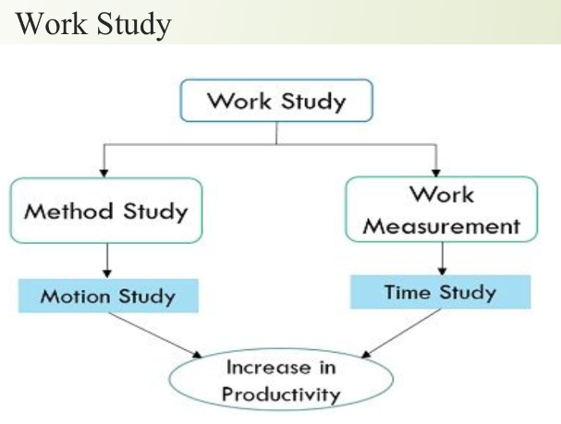

## Time and motion study

## Time study

1. Time study is a method used to measure the time it takes to perform a specific task.
2. Time study focuses on the duration of a task

## Motion study

1. Motion study is a method used to analyze and improve the efficiency of a worker’s movements during a task.
2. Motion study focuses on the workers movements and how they can be optimized.

## Difference between time and motion study

|  |  |
| --- | --- |
| Time study | Motion study |
| Purpose is to determine the standard time for performing a task | Purpose is to improve the efficiency and reduce the unnecessary motions in a task |
| Focuses on measuring and analyzing the time required to complete a task | Focuses on analyzing and improving the movements and actions involved in a task |
| Involves observing and timing a worker performing a task | Involves analyzing and breaking down the task into its individual motions and identifying any unnecessary or inefficient movement |
| Results in a standard time for the task, which can be used for production planning and cost estimation | Results in a redesigned task with improved motions, reducing fatigue and increasing productivity |
| Useful for determining the time required for a new task or process | Useful for improving existing tasks or processes |
| Typically used in manufacturing, assembly, and other types of repetitive work | Typically used in manufacturing, assembly, and other types of repetitive work |
| Developed by Frederick Taylor in 1911 | Developed by Frank and Lillian Gilbreth in the early 1900s |
| Also known as “time and motion study” | Also known as “method study” |

## Methods engineering

1. After first introduction, time study developed in the direction of establishing standard times, while motion study evolved into a technique for improving work methods.
2. These two techniques became integrated and refined into a widely accepted method applicable to the improvement and upgrading of work systems.
3. This integrated approach to work system improvement is known as methods engineering and its applied today to industrial as well as service organizations, including banks, schools and hospitals.
4. A branch of industrial engineering specializing in the analysis of methods and the improvement and standardization of methods, equipment, and working conditions.

## Steps of Methods Engineering

1. Idea
2. Concept
3. Planning
4. Design
5. Development
6. Launch

## Scope of method study

1. To improve work methods and procedures.
2. To determine the best sequence of doing work.
3. To smoothen material flow with minimum of back tracking and to improve layout.
4. To improve the working conditions and hence to improve labor efficiency.
5. To reduce monotony in the work.
6. To improve plant utilization and material utilization.
7. Elimination of waste and unproductive operations.
8. To reduce the manufacturing costs through reducing cycle time of operations.

## Production

1. Transformation of raw materials into finished goods
2. Can be increased by increased input
3. Not a measure of performance
4. Not much effort required to achieve increased production

## Productivity

1. Ratio of output to input
2. Output = final goods
3. Input = resources
4. Measure of performance

## Types of productivity

## Aggregate productivity

1. Total productivity
2. Total factor productivity
3. Return on investment

## Partial productivity

1. Labor
2. Capital
3. Material

## Difference between production Vs Productivity

|  |  |
| --- | --- |
| Production | Productivity |
| Means output of goods or services | Means effective utilization of resources |
| It can be increased by increasing men, material, machines etc. | It can be achieved by reducing wastage of material, man power and machine hours. |
| By increasing production cost of the product will remain same. | By increase in productivity cost of the product will come down. |
| It does not have impact on standard of living. | It certainly improves the standard of living. |
| It changes the raw material into finished product. | It is the ratio between output to input. |

## Why productivity measured

1. To study performance of a system.
2. To attain a relative comparison of different systems for a given level.
3. To compare actual to planned productivity.

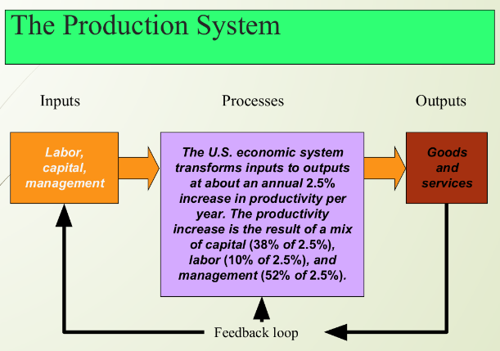

## Production / operation management

1. In the process of managing various subsystems of the organization, the executives at different levels of the organization need to track several management decisions.
2. The management decisions are strategic, tactical and operational.

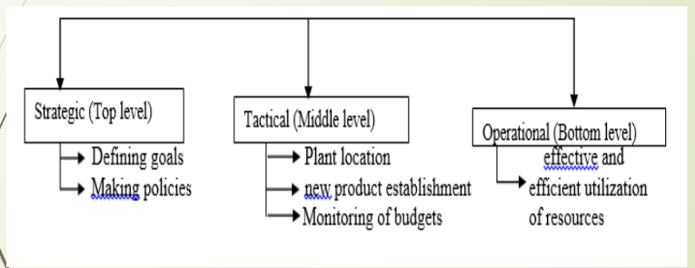

## Factor influencing productivity

Factors influencing productivity can be classified broadly into two categories:

1. Controllable or internal factors
2. Uncontrollable or external factors

## Controllable or internal factors of productivity

1. Management style
2. Material and energy
3. Human factors work method
4. Product factors
5. Plant and equipment technology

## Uncontrollable factors

1. Structural adjustment
2. Natural resources
3. Government and infrastructure

## Possible Quiz Questions

1. List down and explain the different types of work measurement techniques
2. Assuming that the total observed time for an operation of assembling an electric switch is 1.00 min. If the rating is 120%, find normal time. If an allowance of 10% is allowed for the operation, determine the standard time.
3. Explain shortly the controllable factors having the influence in productivity.
4. Explain the basic comparison between time study and motion study.
5. Explain the scope of method study in different areas of manufacturing

## Productivity

$$Productivity=\frac{units produced}{input used}$$

1. Measure of process improvement
2. Represents output relative to input
3. Only through productivity increases can our standard of living improve

## Labor productivity

$$Productivity=\frac{Units produced}{Labor-hours used}$$

$$=\frac{1000}{250}=4\frac{units}{labor hour}$$

If one resource input, that means it is single factor productivity.

## Multi-factor productivity

$$Productivity=\frac{Output}{Labor+Material+Energy+Capital+Miscellaneous}$$

1. Also known as total factor productivity
2. Output and inputs are often expressed in dollars

If multiple resource inputs, that means it is multi-factor productivity.

## Measurement problems

1. Quality may change while the quantity of inputs and outputs remains constant.
2. External elements may cause an increase or decrease in productivity
3. Precise units of measure may be lacking